28.9: The wire carries current in the z-direction. The magnetic field of a small piece of wire 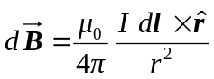 at different locations is therefore:
a) 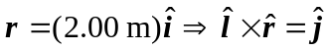
b) 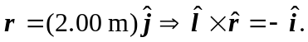
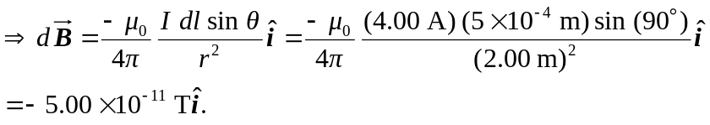

c) 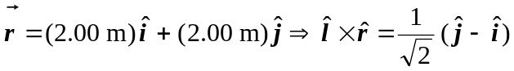
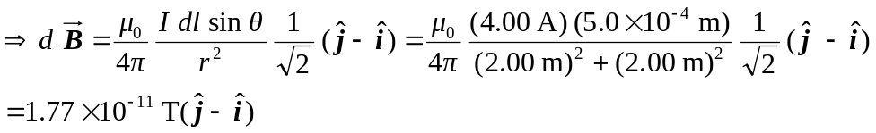

d) 